Using ImageJ for Quantitative Biological Image Analysis

ImageJ / Fiji
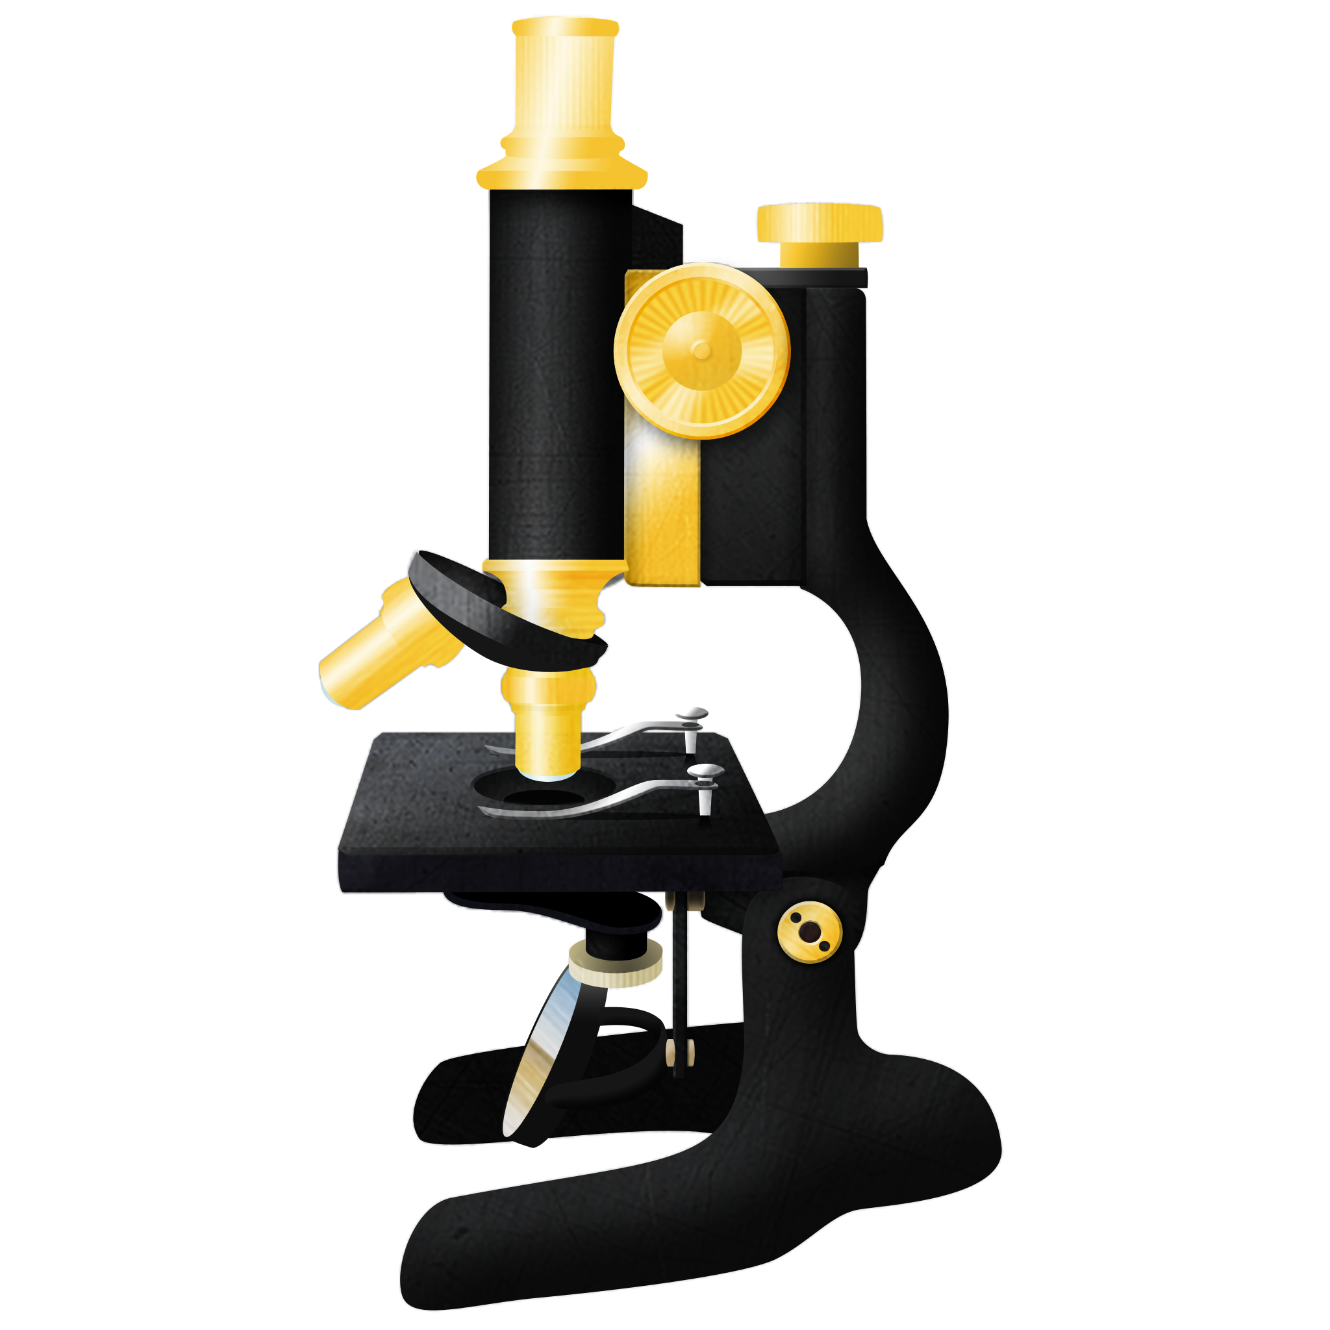
ImageJ is a free, Java-based image analysis program developed by the National Institutes of Health. Since its release in 1997, it has become widely used in scientific research because it is open-source, accessible, and highly customizable.

Because ImageJ is open-source, many plug-ins have been created by the scientific community to expand its functions. These plug-ins allow users to perform a wide range of image analysis tasks, such as cell counting, Z-stack processing, object tracking, and other quantitative measurements.

A widely used version of ImageJ is Fiji, which stands for “Fiji Is Just ImageJ.” Fiji is an ImageJ distribution that comes with many pre-installed plug-ins, particularly those useful for biological and biomedical image analysis.

For the rest of this course, we will use Fiji as our main image analysis platform. You may download Fiji using the button provided.



Fiji Downloads

More detailed information and tutorial can be found here: ImageJ User Guide

Many biological observations are visual. In the laboratory, scientists often observe differences in color, size, number, brightness, shape, or area.
Examples include:

· fruit browning
· cell number
· colony number
· microplate color intensity
· leaf disease area
· root length
· zone of inhibition
· gel band intensity
· fluorescence intensity

Biological Image Type | What ImageJ Can Measure | Biological Interpretation
Fruit or plant tissue images | Color intensity, darkness, area | Browning, disease severity, pigment accumulation
Titer plate or microplate images | Well color intensity | Enzyme activity, antioxidant activity, cell viability, metabolic activity
Microscopy images | Cell number, fluorescence, cell area | Cell density, protein expression, viability, morphology
Agar plates | Colony number, colony size, inhibition zones | Microbial growth, antimicrobial activity
Leaves or roots | Area, length, color | Growth, stress response, disease damage
Gel electrophoresis images | Band intensity, band size | DNA, RNA, or protein abundance

However, visual observations alone can be subjective. For example, one student may describe a sample as “dark,” while another may describe it as “moderately dark.”
ImageJ allows biological images to be analyzed quantitatively. This means that visible observations can be converted into measurable values.
Instead of saying: | we can say:
The sample is darker. | The sample has a corrected intensity value of 120.
There are many cells. | The cell density is 300 cells/mm².

Learning Objectives
After completing this module, you should be able to:
- Explain why biological images can be used as quantitative data.
- Open and prepare images in ImageJ or Fiji.
- Set the scale using a ruler or scale bar.
- Select a region of interest, or ROI.
- Measure area, length, brightness, color intensity, or object number.
- Apply background correction.
- Use thresholding for counting cells, colonies, or stained areas.
- Calculate corrected intensity, percent area, object density, and average diameter.
- Interpret ImageJ results biologically.

Key Concept
ImageJ helps convert images into data.
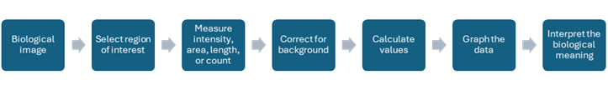
Image File Types
The type of image file used for analysis is an important consideration. Using an unsuitable file format may lead to data loss and may limit the types of analysis that can be performed.
TIFF - Tagged Image File Format
TIFF is a good general-purpose format for image analysis. It stores images without data loss and can retain important metadata together with the image file. TIFF also supports multipage image formats, making it useful for files such as Z-stacks, tile scans, and multi-channel or color images.
Proprietary Image Files - Files generated by microscope or imaging system manufacturers
Proprietary file formats are often the best option when they can be opened by the image analysis software being used. For example, Leica .lif files can be opened in Fiji/ImageJ using the Bio-Formats reader. However, some proprietary files may only be readable using the manufacturer’s own software.
These files usually provide lossless storage and preserve complete metadata. Ideally, the original image data should be kept in its proprietary format, while analyzed or processed versions may be saved in a more general format such as TIFF.
PNG - Portable Network Graphic
PNG is useful for transferring or displaying images. It uses lossless compression, meaning image quality is preserved during saving. However, PNG files generally do not retain the full metadata needed for scientific image analysis.
JPEG - Joint Photographic Experts Group
JPEG files use compression that results in data loss. Because of this, JPEG is not recommended for image quantification or scientific analysis.
However, JPEG files are useful when smaller file sizes are needed, such as for file sharing, posters, reports, or presentations where the highest image quality and complete data preservation are not required.

Basic ImageJ Concepts
1.1 Pixel
A digital image is made of small units called pixels.
In an 8-bit grayscale image:
0 = black 255 = white
This means:
· low gray value = darker
· high gray value = lighter

1.2 Region of Interest
A region of interest, or ROI, is the part of the image selected for measurement.
Examples of ROIs:

· one cell
· one fruit slice
· one microplate well
· one colony
· one leaf
· one gel band
· one inhibition zone
· one stained tissue region

A good ROI should match the biological question being asked.

1.3 Mean Gray Value
Mean gray value is the average brightness of all pixels inside the ROI.
It is useful for measuring:

· darkness
· brightness
· color intensity
· fluorescence intensity
· staining intensity
· gel band intensity

1.4 Area
Area measures the size of the selected ROI.
It is useful for measuring:

· leaf area
· disease area
· cell size
· colony size
· tissue area
· biofilm area

1.5 Integrated Density
Integrated density is the total pixel intensity inside an ROI.
Integrated density = Area × Mean gray value
It is useful when both size and intensity are important, such as in fluorescence or gel band analysis.

1.6 Thresholding
Thresholding separates the object of interest from the background.
It is useful for:

· cell counting
· colony counting
· particle counting
· leaf disease area
· stained tissue area
· biofilm coverage

General ImageJ Workflow

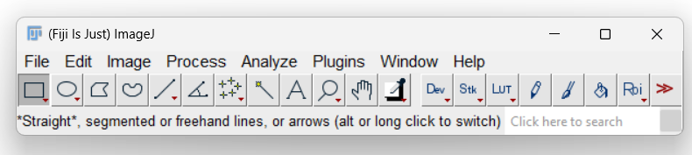

Step 1. Open the Image
In ImageJ:
File → Open
Choose the image file provided.
Good images should have:
· clear focus
· uniform lighting
· minimal shadows
· neutral background
· scale bar or ruler, if needed
· proper labels

Step 2. Set the Scale
If the image has a ruler or scale bar, set the scale.
In ImageJ:
Straight line tool → Draw line along known distance
Analyze → Set Scale
Example:
Known distance: 10
Unit of length: mm
Setting the scale allows ImageJ to convert pixels into real units such as mm, cm, or µm.
This is important for measuring:
· root length
· cell diameter
· leaf area
· colony diameter
· zone of inhibition
Step 3. Prepare the Image
For simple brightness or color analysis:
Image → Type → 8-bit
For color analysis:
Image → Color → Split Channels
For object counting:
Image → Type → 8-bit
Image → Adjust → Threshold
Analyze → Analyze Particles

Step 4. Select the ROI
Use the appropriate tool.
Tool | Best Used For
Rectangle tool | Gel bands, rectangular areas
Oval tool | Microplate wells, round cells, colonies
Polygon tool | Irregular tissue sections
Freehand tool | Leaves, lesions, irregular objects
Wand tool | Areas with clear boundaries
Line tool | Lengths, diameters, scale bars

Important rule:
Use the same ROI method for all samples being compared.

Step 5. Set Measurements
In ImageJ:
Analyze → Set Measurements
Select the measurements needed for your activity.
Common selections:
· Area
· Mean gray value
· Integrated density
· Min and max gray value
· Standard deviation
· Perimeter
· Feret diameter

Step 6. Measure the Sample
After selecting the ROI:
Analyze → Measure
or press:
M
Record your results in the data table.

Step 7. Measure the Background
Background correction is important when lighting or staining is uneven.
Choose a background area that does not contain the biological signal.
Examples:
· blank area beside tissue
· blank well in a titer plate
· unstained region of a slide
· empty agar region
· area beside a gel band

Step 8. Calculate the Corrected Value
Different experiments require different formulas.

Part 3. Important Formulas
3.1 Corrected Dark Signal
Use this when the sample becomes darker than the background.
Corrected dark signal = Background mean gray value - Sample mean gray value
Examples:
· fruit browning
· dark titer plate color
· dark staining
· dark gel bands

3.2 Corrected Bright Signal
Use this when the sample becomes brighter than the background.
Corrected bright signal = Sample mean gray value - Background mean gray value
Examples:
· fluorescence microscopy
· bright staining
· bright gel bands on dark background
· luminescence images

3.3 Corrected Total Fluorescence
Use this when comparing fluorescent objects with different sizes.
Corrected total fluorescence =
Integrated density - (Area × Mean background fluorescence)

3.4 Percent Area
Use this when measuring how much of a region is affected, stained, or covered.
Percent area = (Positive area ÷ Total area) × 100
Examples:
· leaf disease severity
· stained tissue coverage
· biofilm coverage
· cell confluency
3.5 Object Density
Use this when counting cells, colonies, or particles in a known area.
Object density = Object count ÷ Measured area
Examples:
· cells/mm²
· colonies/cm²
· stomata/mm²
· particles/field
3.6 Average Diameter
Use this when measuring circular or irregular zones.
Average diameter = (Diameter 1 + Diameter 2) ÷ 2
Example:
· zone of inhibition
· colony diameter
· lesion diameter

Question 1: What is the main purpose of ImageJ in biological image analysis?
A. To make images look artistic
B. To convert visual biological information into measurable data
C. To replace all laboratory experiments
D. To identify species automatically in all cases
Question 2: A dark-colored assay well has a mean gray value of 120. The blank well has a mean gray value of 230.
What is the corrected dark color intensity?
A. 110
B. 120
C. 230
D. 350
Question 3: Which ImageJ function is most useful for counting cells or colonies after thresholding?
A. Set Scale
B. Analyze Particles
C. Save As
D. Image Crop only
Question 4: Why is background correction important?
A. It changes the biological sample.
B. It removes the need for controls.
C. It reduces error caused by lighting, staining, or camera exposure.
D. It makes all images identical.
Question 5: Why should ImageJ data be interpreted together with biological controls?

Question 6: A student measures a dark colorimetric titer plate assay.
Well | Mean Gray Value | Blank Mean Gray Value
A | 210 | 240
B | 180 | 240
C | 130 | 240
Calculate corrected intensity and rank from weakest to strongest reaction.
Answer Key:
Question 1: What is the main purpose of ImageJ in biological image analysis?
Answer: B. To convert visual biological information into measurable data.
Explanation: ImageJ helps quantify features such as intensity, area, length, and object number.

Question 2: A dark-colored assay well has a mean gray value of 120. The blank well has a mean gray value of 230.
What is the corrected dark color intensity?
Answer: A. 110
Calculation: Corrected intensity = 230 - 120 = 110

Question 3: Which ImageJ function is most useful for counting cells or colonies after thresholding?
Answer: B. Analyze Particles
Explanation: Analyze Particles counts objects that have been separated from the background by thresholding.

Question 4: Why is background correction important?
Answer: C. It reduces error caused by lighting, staining, or camera exposure.

Question 5: Why should ImageJ data be interpreted together with biological controls?
Answer: ImageJ data should be interpreted with biological controls because image measurements show visual patterns, not the mechanism by themselves. Controls help determine whether the observed pattern is biologically meaningful.

Question 6: A student measures a dark colorimetric titer plate assay.
Well | Mean Gray Value | Blank Mean Gray Value
A | 210 | 240
B | 180 | 240
C | 130 | 240
Calculate corrected intensity and rank from weakest to strongest reaction.
Answer
Well | Corrected Intensity
A | 30
B | 60
C | 110
Ranking:
Weakest: A
Intermediate: B
Strongest: C

